EFIS No. 68/2004

December 2004

RANGE: PROBATE

PROPEP2005 - Probate Estate Provisions (Notes)

The Non Contentious Probate Fees Order 2004 will reduce the fee for the application of a grant where the value of the deceased’s estate exceeds £5,000 from £50 to £40 on 4th January 2005.

We have therefore amended the Probate Estate Provisions Sheet to reflect these amendments.

Practitioners should not use this latest PEP sheet with Probate forms PRO4, PRO4B, PRO5, PRO8, PRO9, PRO11, PRO12, PRO13, PRO14 or PRO16 in respect of applications submitted before 4th January next year.

You are advised to delete PROPEP2004 for your system(s). See deletion instructions overleaf.

**NEW RANGE - COMMONHOLD**
Please contact the Sales on Tel: 020 7556 3200 for a quote, or email sales.legal.software@oyezstraker.co.uk

** OYEZFORMS LATEST VERSION V8.06B - FORTHCOMING SDLT FORM RELEASE **
OyezForms will now attempt to register AXPDF417.OCX at the first print job. If the file cannot be registered a warning message will appear and NO form will print. Please note that the PDF417 barcode technology, which has been incorporated into OyezForms as per Inland Revenue guidelines, is not compatible with Windows 95. Therefore, Windows 98+, or NT4 SP6+ is required. For further information please visit http://www.winbarcode.com/faq.php.
To obtain an upgrade, please visit http://www.oyezforms.co.uk/ or contact Support on Tel: 020 7556 3201 or email mailto:support.legal.software@oyezstraker.co.uk

You can visit www.oyezforms.co.uk to keep up to date with the latest news and what new services OyezForms has to offer, or to register for email notification of EFIS updates. To register for email notification updates, mail us at: legal.email@oyezstraker.co.uk, including your company name and oyez account number in the message text.

Importing Forms – Version 8 (32Bit software for Windows 98/NT4/2000/XP)

- Start the OyezForms software (if you are running a networked copy of the software only one user should have the software open at this point).
- Insert the floppy disk into your floppy drive.
- Select Admin and then Import new forms…
- The Import new forms dialog box will appear and a list of the forms contained on the floppy disk will be displayed.
- Click Select All and then Import.
- Once complete you will be asked if there are any more forms to import. If no click No.
If Yes; insert the next disk and click Ok.
- The screen will refresh to display a new list of forms. Follow step 5 again.
- Once all the disk(s) have all been imported click No.

Deleting Forms – Version 8 (32Bit software for Windows 98/NT4/2000/XP)

- Click ADMIN>LIBRARY MAINTENANCE, then double-click MASTER>PROBATE
- Highlight obsolete form(s) (PROPEP2004) using the left mouse and press the Delete button on screen.
- The software will pop-up two ‘Are you Sure’ messages, click Yes to both.
- Finally, click Done button on screen.

Example Screen Shot – Library Maintenance:

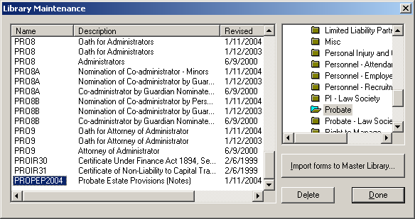

If you have any problems please contact Oyez Legal Software on 020 7556 3201

