EFIS No. 51/2004

September 2004

RANGE: LEGAL AID (LEGAL SERVICES COMMISSION)

CDS3 - Application for Advocacy Assistance Representation
CDS7 - Non-Standard Fee Contract Work Assessment Form
CLSADMIN1 - Preservation or Recovery Under the Statutory Charge and Request to
Postpone Enforcement
CLSAPP3 - Application for CLS Funding Certificate. General Family Help and Legal
Representation in Family Proceedings
CLSAPP5 - Application for CLS Funding Certificate - Special Children Act Proceedings
CLSAPP8 - Application for amendment or Prior Authority in Civil Cases
CLSCLAIM1 - Claim for Assessment of Costs or Payment of Costs Following
Detailed Assessment In Civil Cases
CLAIM1 CHECKLIST - Checklist for CLSCLAIM1
CRIM_7 - Notice of Application Relating to Bail to be made to the Crown Court
CRIM_8 - Notice of Appeal to Crown Court
CWORK1 - Legal Help and Help at Court
CWORK3(IM) - Application for an Extension – Controlled Work(Immigration)
LSCFR1 - File Review Report and Claim Form

The Legal Services Commission has amended the above forms in accordance with changes in Government policy and legislation.

These amended forms must be used from 4th October as regional offices of the Legal Services Commission will reject old versions, submitted after this date.

Two new forms have also been added to the range, CRIM_7 and CRIM_8 for use in the Crown Court.

We have also made minor field and textual amendments to forms CMRF and CLSCLM1(P5).

In addition to the amendments made by The Legal Services Commission we have also made substantial
changes to the macros for form CDS7 at the request of customers and with advice given by the LSC.

Finally, whilst writing we ask that you please delete form LAWKNOTE from your system(s) should it appear, as it no longer forms part of the Master Pack. Please see deletion instructions overleaf.

**NEW RANGE - COMMONHOLD**
Please contact the Sales on Tel: 020 7556 3200 for a quote, or email sales.legal.software@oyezstraker.co.uk

** OYEZFORMS LATEST VERSION V8.06A - FORTHCOMING SDLT FORM RELEASE **
OyezForms will now attempt to register AXPDF417.OCX at the first print job. If the file cannot be registered a warning message will appear and NO form will print. Please note that the PDF417 barcode technology, which has been incorporated into OyezForms as per Inland Revenue guidelines, is not compatible with Windows 95. Therefore, Windows 98+, or NT4 SP6+ is required. For further information please visit http://www.winbarcode.com/faq.php.
To obtain an upgrade, please visit http://www.oyezforms.co.uk/ or contact Support on Tel: 020 7556 3201 or email mailto:support.legal.software@oyezstraker.co.uk

You can visit www.oyezforms.co.uk to keep up to date with the latest news and what new services OyezForms has to offer, or to register for email notification of EFIS updates. To register for email notification updates, mail us at: legal.email@oyezstraker.co.uk, including your company name and oyez account number in the message text.

Importing Forms – Version 8 (32Bit software for Windows 98/NT4/2000/XP)

- Start the OyezForms software (if you are running a networked copy of the software only one user should have the software open at this point).
- Insert the floppy disk into your floppy drive.
- Select Admin and then Import new forms…
- The Import new forms dialog box will appear and a list of the forms contained on the floppy disk will be displayed.
- Click Select All and then Import.
- Once complete you will be asked if there are any more forms to import. If no click No.
If Yes; insert the next disk and click Ok.
- The screen will refresh to display a new list of forms. Follow step 5 again.
- Once all the disk(s) have all been imported click No.

Deleting Forms – Version 8 (32Bit software for Windows 98/NT4/2000/XP)

- Click ADMIN>LIBRARY MAINTENANCE, then double-click MASTER>LEGAL AID
- Highlight obsolete form(s) (LAWKNOTE) and press the Delete button on screen.
- The software will pop-up two ‘Are you Sure’ messages, click Yes to both.
- Finally, click Done button on screen.

Example Screen Shot – Library Maintenance:

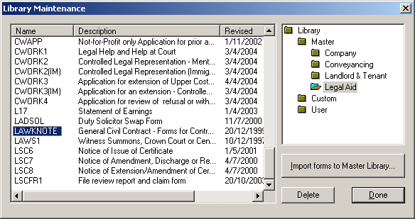

If you have any problems please contact Oyez Legal Software on 020 7556 3201

