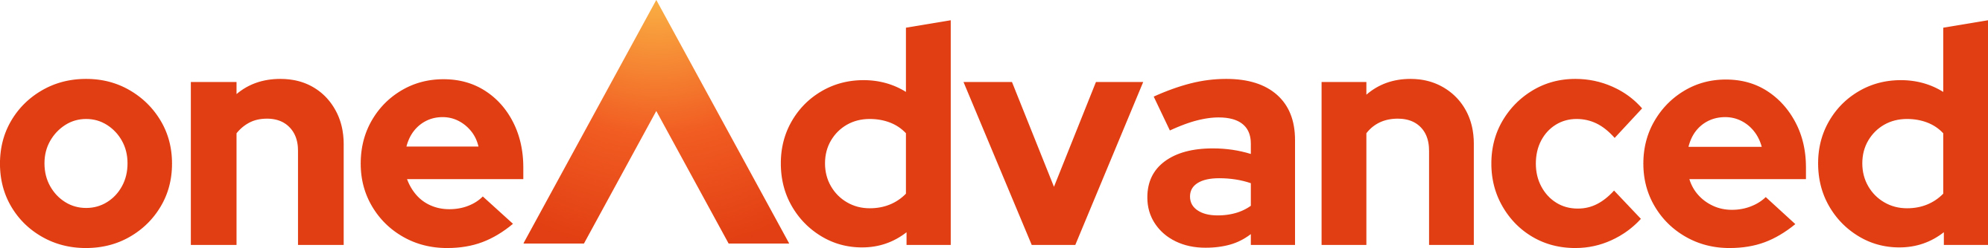 Legal Forms
Form Updates for OyezForms

Update No: 44/2025 Date: 9th June 2025

Children Act
.

HMCTS have updated the following form which is now available for immediate use.

□ | C63 | Application for declaration of parentage under section 55A of the Family Law Act 1986 - [CA63]

