EFIS No.44/2004

September 2004

RANGE: DIVORCE

DIV8 - Statement of Arrangements for Children
EX160 - Application for Fee Exemption or Remission
EX160(N) - Notes for EX160

The Family Proceedings Fees (Amendment) Order 2004 came into force on 31st August and increases the income threshold to £14,600 from the present limit of £14,213.

The Statutory Instrument stipulates that child tax credit need not necessarily be received by the party seeking exemption from court fees, provided that it is paid in respect of a joint claim made by the party and his or her spouse or partner.

The Court Service has made amendments to both EX160 form and accompanying notes in the light of these changes. Some minor text alignment amendments have also been made to the DIV8.

The above mentioned forms are enclosed for your immediate use.

Whilst writing we ask that you please delete the following forms from your system(s) should they appear, as we are no longer maintaining these forms:

DIV46 - Originating Application for Alteration of Maintenance Agreement during Parties’ Lifetime
DIV47 - Originating Application for Alteration of Maintenance Agreement after Death of One of the
Parties
DIV71 - Affidavit of Service (General Form) (High Court only)
DIV73 - Notice to Product at Trail (High Court only)
DIV78 - Praecipe of Writ of Fi Fa (High Court only)
DIV79 - Writ of Fi Fa (High Court only)
DIV91 - Originating Summons under s.1 of Inheritance (Provision for Family and Dependents) Act
1975 (High Court)

**NEW RANGE - COMMONHOLD**
Please contact the Sales on Tel: 020 7556 3200 for a quote, or email sales.legal.software@oyezstraker.co.uk

** OYEZFORMS LATEST VERSION V8.06A - FORTHCOMING SDLT FORM RELEASE **
OyezForms will now attempt to register AXPDF417.OCX at the first print job. If the file cannot be registered a warning message will appear and NO form will print. Please note that the PDF417 barcode technology, which has been incorporated into OyezForms as per Inland Revenue guidelines, is not compatible with Windows 95. Therefore, Windows 98+, or NT4 SP6+ is required. For further information please visit http://www.winbarcode.com/faq.php.
To obtain an upgrade, please visit http://www.oyezforms.co.uk/ or contact Support on Tel: 020 7556 3201 or email mailto:support.legal.software@oyezstraker.co.uk

You can visit www.oyezforms.co.uk to keep up to date with the latest news and what new services OyezForms has to offer, or to register for email notification of EFIS updates. To register for email notification updates, mail us at: legal.email@oyezstraker.co.uk, including your company name and oyez account number in the message text.

Importing Forms – Version 8 (32Bit software for Windows 98/NT4/2000/XP)

- Start the OyezForms software (if you are running a networked copy of the software only one user should have the software open at this point).
- Insert the floppy disk into your floppy drive.
- Select Admin and then Import new forms…
- The Import new forms dialog box will appear and a list of the forms contained on the floppy disk will be displayed.
- Click Select All and then Import.
- Once complete you will be asked if there are any more forms to import. If no click No.
If Yes; insert the next disk and click Ok.
- The screen will refresh to display a new list of forms. Follow step 5 again.
- Once all the disk(s) have all been imported click No.

Deleting Forms – Version 8 (32Bit software for Windows 98/NT4/2000/XP)

- Click ADMIN>LIBRARY MAINTENANCE, then double-click MASTER>DIVORCE
- Highlight obsolete forms DIV46, DIV47, DIV71, DIV73, DIV78, DIV79, DIV91 using the left mouse and press the Delete button on screen.
- The software will pop-up two ‘Are you Sure’ messages, click Yes to both.
- Finally, click Done button on screen.

Example Screen Shot – Library Maintenance:

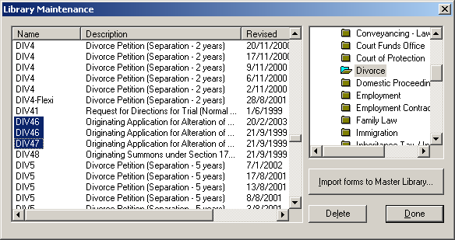

If you have any problems please contact Oyez Legal Software on 020 7556 3201

