EFIS No.32/2004

June 2004

RANGE: LIMITED LIABILITY PARTNERSHIPS

LLP2 - Application for Incorporation of a Limited Liability Partnership
LLP3 - Notice of Change of Name of a Limited Liability Partnership
LLP8 - Notice of Designated Member(s) of a Limited Liability Partnership
LLP190 - Location of register of debenture holders of a Limited Liability Partnership
LLP225 - Chance of accounting reference date of a Limited Liability Partnership
LLP244 - Notice of claim to extension of period allowed for laying and delivering accounts –
oversea business or interests of a Limited Liability Partnership
LLP287 - Change in situation or address of Registered Office of a Limited Liability Partnership
LLP287a - Notice that the Registered Office of a Limited Liability Partnership is Situated in Wales
LLP288a - Appointment of a Member to a Limited Liability Partnership
LLP288b - Terminating the membership of a member of a Limited Liability Partnership
LLP288c - Change of Particulars of a member of a Limited Liability Partnership
LLP363 - Annual Return of a Limited Liability Partnership
LLP391 - Notice of removal of auditor from a Limited Liability Partnership
LLP395 - Particulars of a mortgage or charge in respect of a Limited Liability Partnership
LLP397 - Particulars for the registration of a charge to secure a series of debentures in respect of a Limited Liability Partnership
LLP397a - Particulars of an issue of secured debentures in a series in respect of a Limited Liability Partnership
LLP398 - Certificate of registration in Scotland or Northern Ireland of a charge comprising property situated there
LLP400 - Particulars of a mortgage or charge on a property that has been acquired by a Limited Liability Partnership
LLP403a - Declaration of satisfaction in full or in part of mortgage or charge
LLP403b - Declaration that part of the property or undertaking charged (a) has been released from the charge (b) no longer forms part of the limited liability partnership’s property or undertaking
LLP405(1) - Notice of appointment of receiver or manager in respect of Limited Liability Partnership
LLP405(2) - Notice of ceasing to act as a receiver or manager in respect of a Limited Liability Partnership
LLP410 - Particulars of a charge created by a Limited Liability Partnership registered in Scotland
LLP413 - Particulars for the registration of a charge to secure a series of debentures in respect of a Limited Liability Partnership (note 1)
LLP413a - Particulars of an issue of Debentures out of a series of secured Debentures in respect of a Limited Liability Partnership (note 1)
LLP416 - Particulars of a charge subject to which property has been acquired by a Limited Liability Partnership registered in Scotland
LLP419a - Limited Liability Partnership: Memorandum of satisfaction in full or in part of a registered charge
LLP419b - Memorandum of fact that proof of a property charged (a) has been released from the charge (b) no longer forms part of the LLP’s property
LLP466 - Particulars of an instrument of alteration to a floating charge created by a Limited Liability Partnership registered in Scotland
LLP652a - Application for striking off a Limited Liability Partnership
LLP652c - Withdrawal of application for striking off a Limited Liability Partnership

Companies House has made some slight changes to these Limited Liability Partnership forms which practitioners may use upon receipt of this disk.

Please note that form LLP405-2 has been renamed to LLP405(2).

Therefore, please delete form LLP405-2 from your system(s) immediately. Please see deletion instructions overleaf.

Deleting Forms – Version 8 (32Bit software for Windows 98/NT4/2000/XP)

- Click ADMIN>LIBRARY MAINTENANCE, then double-click MASTER> Limited Liability Partnership.
- Highlight obsolete form LLP405-2 by clicking with the left mouse button, then click the “Delete” button.
- The software will pop-up two ‘Are you Sure’ messages, click Yes to both.
- Finally, click Done button on screen.

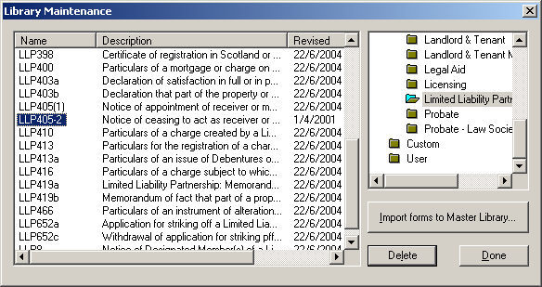
Example Screen Shot – Library Maintenance:

Importing Forms – Version 8 (32Bit software for Windows 98/NT4/2000/XP)

- Start the OyezForms software (if you are running a networked copy of the software only one user has the software open at this point).
- Insert the update disk into your floppy drive.
- Select Admin and then Import new forms…
- The Import new forms dialog box will appear and a list of the forms contained on the update disk will be displayed. Click Select All and then Import.
- Once imported you will be asked if there are any more forms to import. If there are click Yes; insert the next disk and select OK.
- The screen will refresh to display a new list of forms. Follow step 4 again.
- Once the disk(s) have all been imported select No.

If you have any problems please contact Oyez Legal Software on 020 7556 3201

