EFIS No.30/2003

July 2003

RANGE: PROBATE

PROPEP2003 – Probate Estate Provisions [Notes]

Earlier this year, the Chancellor of the Exchequer announced changes in the Budget to the threshold at which Inheritance Tax becomes payable on a deceased person’s estate.

The Inheritance Tax (Delivery of Accounts) (Excepted Estates) Regulations 2003 will come into force on 1st August and prescribe the figure of £240,000 in respect of deaths which occur on or after 6th April 2003.

In addition, PROPEP2003 has been further amended to reflect the provisions of the Non-Contentious Probate Fees (Amendment) Order 2003 which came into force on 30th May 2003 and applied a reduced fee of £8.00 in respect of people exempt by virtue of Section 154 of the Inheritance Tax Act 1984 (e.g. members of the armed services who are killed in military action on or after 20th March 2003).

PROPEP2003 replaces PROPEP2002 so unless your firm may need to refer to PROPEP2002 in respect of Probate applications lodged before 1st August 2003, we would suggest that you delete PROPEP2002 from your system on or before 31st July. Please see deletion instructions overleaf.

PROPEP2003 is a set of notes which are used to help practitioners complete forms PRO4, 4B, 5, 5B, 8, 9, 11, 12, 13, 14, 15 and 16 and should not be used before 1st August 2003 In accordance with the 2003 Regulations.

You can visit www.oyezforms.co.uk to keep up to date with the latest news and what new services Oyezforms has to offer, or to register for email notification of EFIS updates. To register for email notification updates, mail us at: legal.email@oyezstraker.co.uk, including your company name and oyez account number in the message text.

** NEW SEARCH FACILITY V8.04A or Above **
New search facility added to the File > New dialogue. Now able to search by Form Name, Description and Category in the Master, Custom and User libraries. To obtain an upgrade, please visit http://www.oyezforms.co.uk/ or contact Support on Tel: 020 7556 3201 or email mailto:support.legal.software@oyezstraker.co.uk

New Ranges
Due to popular demand we have added the following ranges: Insolvency Partnership and Estates, Personal Injury/Consumer Protection, Court Funds Office, Licensing, Betting and Gaming, Limited Liability Partnership, Admiralty, Domestic Proceedings, Commercial Conditions – Law Society and Personal Injury – Law Society forms to OyezForms. For a list of these forms please access Help>Oyez Forms Catalogue once your enclosed update disk has been installed. Please contact the Sales Department on 020 7556 3200 if you would like a quote for any of these new ranges.

Importing Forms – Version 7&8 (32Bit software for Win95/98/NT4/2000/XP)

- Start the OyezForms software (if you are running a networked copy of the software only one user has the software open at this point).
- Insert the update disk into your floppy drive.
- Select Admin and then Import new forms…
- The Import new forms dialog box will appear and a list of the forms contained on the update disk will be displayed. Click Select All and then Import.
- Once imported you will be asked if there are any more forms to import. If there are click Yes; insert the next disk and select OK.
- The screen will refresh to display a new list of forms. Follow step 4 again.
- Once the disk(s) have all been imported select No. Click Done

Deleting Files under Windows 95/98/2000/NT/XP for Version 7 & 8

- Click ADMIN>LIBRARY MAINTENANCE, then double-click
MASTER>PROBATE
- Highlight obsolete form (PROPEP2002) and press the Delete button on screen.
- The software will pop-up two ‘Are you Sure’ messages, click Yes to both.
- Repeat for subsequent forms (if applicable).
- Finally, click Done button on screen.

Example Screen Shot – Library Maintenance:

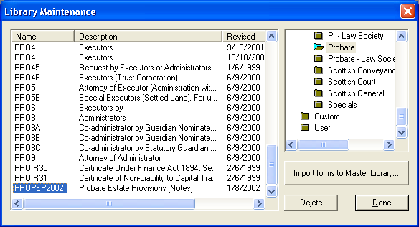

If you have any problems please contact Oyez Legal Software on 020 7556 3201

