EFIS No.29/2003

June 2003

RANGE: INLAND REVENUE / INHERITANCE TAX

IR185 - Certificate of Deduction of Income Tax
IR185EI - Statement of Estate Income
IR185TI - Statement of Income from Trusts

The Inland Revenue has recently completed a review of its IR185 series of forms.

Whereas trustees of discretionary trusts used to notify beneficiaries of payments to them on IR185 and trustees of interest in possession trusts used form IR185NDT to notify beneficiaries of their annual income under the trust, only the new form IR185TI should now be used and IR185NDT will no longer be required. Therefore, IR185NDT must be removed from your systems. Please see deletion instructions overleaf.

Practitioners will note that the box numbers on IR185TI correspond to the same numbers which appear on the Trust income pages of the Self-Assessment tax return.

The Inland Revenue has also enhanced the design of IR185EI and amended IR185 to cater for applications concerning income derived from loan interest and rent which do not affect trusts.

Practitioners should use these amended forms immediately on receipt of this disk.

You can visit www.oyezforms.co.uk to keep up to date with the latest news and what new services Oyezforms has to offer, or to register for email notification of EFIS updates. To register for email notification updates, mail us at: legal.email@oyezstraker.co.uk, including your company name and oyez account number in the message text.

** NEW SEARCH FACILITY V8.04A or Above **
New search facility added to the File > New dialogue. Now able to search by Form Name, Description and Category in the Master, Custom and User libraries. To obtain an upgrade, please visit http://www.oyezforms.co.uk/ or contact Support on Tel: 020 7556 3201 or email mailto:support.legal.software@oyezstraker.co.uk

New Ranges
Due to popular demand we have added the following ranges: Insolvency Partnership and Estates, Personal Injury/Consumer Protection, Court Funds Office, Licensing, Betting and Gaming, Limited Liability Partnership, Admiralty, Domestic Proceedings, Commercial Conditions – Law Society and Personal Injury – Law Society forms to OyezForms. For a list of these forms please access Help>Oyez Forms Catalogue once your enclosed update disk has been installed. Please contact the Sales Department on 020 7556 3200 if you would like a quote for any of these new ranges.

Importing Forms – Version 7&8 (32Bit software for Win95/98/NT4/2000/XP)

- Start the OyezForms software (if you are running a networked copy of the software only one user has the software open at this point).
- Insert the update disk into your floppy drive.
- Select Admin and then Import new forms…
- The Import new forms dialog box will appear and a list of the forms contained on the update disk will be displayed. Click Select All and then Import.
- Once imported you will be asked if there are any more forms to import. If there are click Yes; insert the next disk and select OK.
- The screen will refresh to display a new list of forms. Follow step 4 again.
- Once the disk(s) have all been imported select No. Click Done

Deleting Files under Windows 95/98/2000/NT/XP for Version 7 & 8

- Click ADMIN>LIBRARY MAINTENANCE, then double-click
MASTER>INHERITANCE TAX / INLAND REVENUE
- Highlight obsolete form (IR185NDT) and press the Delete button on screen.
- The software will pop-up two ‘Are you Sure’ messages, click Yes to both.
- Repeat for subsequent forms (if applicable).
- Finally, click Done button on screen.

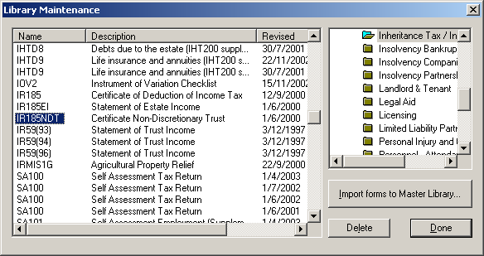
Example Screen Shot – Library Maintenance:

If you have any problems please contact Oyez Legal Software on 020 7556 3201

