EFIS No 26/2004

June 2004

RANGE: COMMERCIAL CONDITIONS – Law Society

SCPC1_2 - Standard Commercial Property Conditions
SCPC_Notes - Explanatory Notes on The Standard Commercial Property Conditions (Second Edition) (Published 1st June 2004)
CON14F - Notice to Complete under Condition 8 of the Standard Commercial Property Conditions
CON293 - Enquiries before Contract for Sale of a Company

We are pleased to offer you the second edition of the Standard Commercial Property Conditions of Sale on disk and explanatory notes to accompany the SCPC1_2 which highlight the differences from the previous edition of the form.

An article explaining the background to the amendments to SCPC will appear in a future edition of the Law Society’s Gazette.

Therefore, SCPC1 needs to be deleted from your system(s) immediately. Please see deletion instructions overleaf.

In addition, CON14F has also been amended to take account of various alterations to the SCPC.

Finally, unrelated to these amendments, we have made a minor alteration to CON293 to delete the reference to sections 82 to 91 of the Finance Act 1984.

Practitioners can use the amended versions of these forms immediately.

**NEW RANGE - RIGHT TO MANAGE**
Please contact the Sales on Tel: 020 7556 3200 for a quote, or email sales.legal.software@oyezstraker.co.uk

** OYEZFORMS LATEST VERSION V 8.05F - FORTHCOMING SDLT FORM RELEASE **
OyezForms will now attempt to register AXPDF417.OCX at the first print job. If the file cannot be registered a warning message will appear and NO form will print. Please note that the PDF417 barcode technology, which has been incorporated into OyezForms as per Inland Revenue guidelines, is not compatible with Windows 95. Therefore, Windows 98+, or NT4 SP6+ is required. For further information please visit http://www.winbarcode.com/faq.php.
To obtain an upgrade, please visit http://www.oyezforms.co.uk/ or contact Support on Tel: 020 7556 3201 or email mailto:support.legal.software@oyezstraker.co.uk

You can visit www.oyezforms.co.uk to keep up to date with the latest news and what new services OyezForms has to offer, or to register for email notification of EFIS updates. To register for email notification updates, mail us at: legal.email@oyezstraker.co.uk, including your company name and oyez account number in the message text.

An Online Forms Catalogue, updated automatically with each EFIS, is available within the OyezForms >HELP Menu or START>PROGRAMS>OYEZLEGALFORMS>OYEZFORMS CATALOGUE.

Importing Forms – Version 8 (32Bit software for Windows 98/NT4/2000/XP)

- Start the OyezForms software (if you are running a networked copy of the software only one user has the
software open at this point).
- Insert the update disk into your floppy drive.
- Select Admin and then Import new forms…
- The Import new forms dialog box will appear and a list of the forms contained on the update disk will be displayed. Click Select All and then Import.
- Once imported you will be asked if there are any more forms to import. If there are click Yes; insert the next disk and select OK.
- The screen will refresh to display a new list of forms. Follow step 4 again.
Once the disk(s) have all been imported select No.

Deleting Files under Windows 98/2000/NT/XP for Version 8

- Click ADMIN>LIBRARY MAINTENANCE, then double-click MASTER>COMMERCIAL CONDITION – Law Society
- Highlight obsolete form (SCPC1) and press the Delete button on screen.
- The software will pop-up two ‘Are you Sure’ messages, click Yes to both.
- Repeat for subsequent forms (if applicable).
- Finally, click Done button on screen.

Example Screen Shot – Library Maintenance:

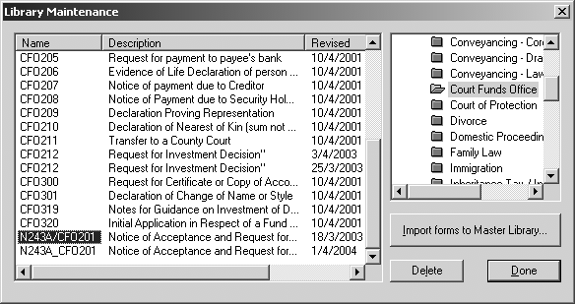

If you have any problems please contact Oyez Legal Software on 020 7556 3201

