EFIS No. 22/2004

May 2004
***************************************************************************************************************************
IMPORTANT NOTICE: Please delete existing forms L&T24, L&T25A, L&T25B, L&T26, L&T28, L&T29, L&T30 and HUD11 BEFORE importing new form templates.
**********************************************************************************************************************************************************

RANGE: LANDLORD AND TENANT

L&T24SR - Landlord’s Notice Ending a Business Tenancy (With Reasons for Refusing a New Tenancy) Where the Leasehold Reform Act 1967 May Apply [FORM7]
L&T25(1) - Landlord’s Notice Ending a Business Tenancy with Proposals for a New One [FORM1]
L&T25(2) - Landlord’s Notice Ending a Business Tenancy and Reasons for Refusing a New One [FORM2]
L&T25B - Landlord’s Withdrawal of Notice Terminating Tenancy [FORM6]
L&T26 - Tenant’s Request for a New Business Tenancy [FORM3]
L&T28 - Landlord’s Request for Information About Occupation and Sub-Tenancies [FORM4]
L&T29SR - Tenant’s Request for Information from Landlord or Landlord’s Mortgagee About Landlord’s Interest [FORM5]

The Landlord and Tenant Act 1954 Part 2 (Notices) England and Wales) Regulations 2004 prescribe new and amended forms for use from 1st June 2004 in connection with new procedures for applications under the 1954 Act in both England and Wales.

Practitioners are advised that existing Landlord and Tenant forms L&T24, L&T25A, L&T25B, L&T26, L&T28, L&T29, L&T30 and HUD11 should not be used after 31st May and should be removed from your system(s) before the end of May. **Please see deletion instructions overleaf**

Oyez’s own non-prescribed form L&T27 can continue to be used but L&T25A has been made obsolete by these Rule changes.

In addition, however, we will also be adding the following forms to your range which are prescribed under the Regulatory Reform (Business Tenancies) (England And Wales) Order 2003 which will also come into force on 1st June.

L&T35 - Form of Notice that Sections 24 to 28 of the Landlord and Tenant Act 1954 are not to Apply to a Business Tenancy
L&T35A - Simple Declaration that Sections 24 to 28 of the Landlord and Tenant Act 1954 are not to Apply to a Business Tenancy
L&T35B - Statutory Declaration that Sections 24 to 28 of the Landlord and Tenant Act 1954 are not to Apply to a Business Tenancy
L&T36 - Form of Notice that an Agreement to Surrender a Business Tenancy is to be Made
L&T36A - Simple Declaration that an Agreement to Surrender a Business Tenancy is to be Made
L&T36B - Statutory Declaration that an Agreement to Surrender a Business Tenancy is to be Made

In future, a landlord and tenant will no longer have to apply for a court order, approving exclusion of security of tenure granted under the 1954 Act.

Instead, a landlord can serve L&T35 on a tenant 14 days before the tenant signs a new lease relinquishing security of tenure. Before such an agreement is valid, the tenant declares in L&T35A that he or she received the warning notice in L&T35 and understands its significance. Where both the landlord and tenant are happy to ignore the 14-day period, (for example due to the need to quickly occupy premises because of a fire) the tenant makes a statutory declaration, using L&T35B.

Where both parties wish to make an agreement to surrender a business tenancy, the landlord serves the tenant with L&T36. L&T36A is the declaration and L&T36B the statutory declaration.

AGREE14B - Agreement for Letting Farm on a Farm Business Tenancy
ATA1 - Notice of Intention to Create a Farm Business Tenancy of Identified Land
HA5 - Tenant’s Notice Requiring (Re) Determination of Value
HA7 - Notice of Effect of (Re) Determination of Value
HA10A - Landlord’s Preliminary Notice to Complete
HA10B - Landlord’s Final Notice to Complete
HA39 - Notice Claiming the Right to Acquire on Rent to Mortgage Terms
INVEN - Inventory
RG - Rent Guarantee

In an endeavour to provide our customers with as wide a range of forms as possible, the above forms have also been added to your Landlord and Tenant range.

Finally, on an unrelated matter, HUD8 has had minor amendments and is enclosed for your immediate use.

Deleting Forms – Version 8 (32Bit software for Windows 98/NT4/2000/XP)

- Click ADMIN>LIBRARY MAINTENANCE, then double-click MASTER>LANDLORD & TENANT
- Highlight obsolete forms (L&T24, L&T25A, L&T25B, L&T26, L&T28, L&T29, L&T30 and HUD11) using the Shift and Page Down or Arrow Down keys on the keyboard and press the Delete button on screen.
- The software will pop-up two ‘Are you Sure’ messages, click Yes to both.
- Repeat for subsequent forms.
- Finally, click Done button on screen.

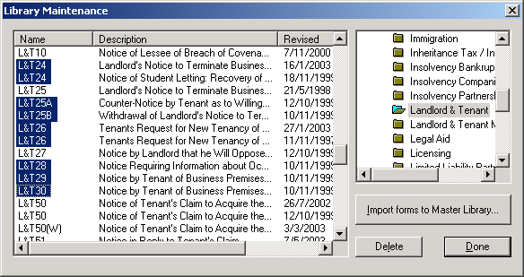
Example Screen Shot – Library Maintenance:

Importing Forms – Version 8 (32Bit software for Windows 98/NT4/2000/XP)

- Start the OyezForms software (if you are running a networked copy of the software only one user has the software open at this point).
- Insert the update disk into your floppy drive.
- Select Admin and then Import new forms…
- The Import new forms dialog box will appear and a list of the forms contained on the update disk will be displayed. Click Select All and then Import.
- Once imported you will be asked if there are any more forms to import. If there are click Yes; insert the next disk and select OK.
- The screen will refresh to display a new list of forms. Follow step 4 again.
- Once the disk(s) have all been imported select No.

If you have any problems please contact Oyez Legal Software on 020 7556 3201

