EFIS No.14/2004

March 2004

RANGE: CIVIL PROCEDURE

N5 - Claim Form for Possession of Property
N293A - Combined Certificate of Judgement and Request for Writ of Fieri Facias or Writ of
Possession
N322H - Request to Register a High Court Judgment or Order for Enforcement
HCNO53 - Writ of Fieri Facias
HCNO54 - Writ on Fieri Facias on Order for Costs
HCNO56 - Writ of Fieri Facias After Levy of Part
HCNO57 - Writ of Fieri Facias Against Personal Representatives
HCNO64 - Writ of Delivery: Delivery of Goods, Damages and Costs
HCNO65 - Writ of Delivery: Delivery of Goods or Value, Damages and Costs
HCNO66 - Writ of Possession
HCNO66A - Writ of Possession
HCNO71 - Notice of Renewal of Writ of Execution
CFO100 - Request for Lodgment
N243A_CFO201 - Notice of Acceptance and Request for Payment

The Courts Act 2003 (Commencement No.3 and Transitional Provisions) Order 2004 and the High Court Enforcement Officers Regulations 2004 came into force on 15th March.

These Regulations implement section 99 of the Courts Act 2003, which provides for the enforcement of writs of execution by enforcement officers instead of sheriffs.

The Court Service has therefore amended the above-mentioned forms from 1st April, so practitioners should use these amended forms from the beginning of next month.

In addition, the Court Service has amended the text and notes for guidance on CFO100 and added comprehensive guidance notes on the reverse of N243A_CFO201.

We have also taken the opportunity to make some minor textural amendments on forms N323, N445 and N379.

Practitioners are advised that N255, N255(HC), N256 and N256(HC) have also been amended but will no longer be published by Oyez because N255 and N256 will in future be generated by the Caseman system in the county courts.

Therefore, N255, N255(HC), N256, and N256(HC) should be deleted from your system(s) immediately. Please see deletion instructions overleaf.

Also, please note that form N243A/CFO201 has been renamed to N243A_CFO201. The name change is due to problems experienced by Case Management suppliers who were unable to Automate with the previous version that contained the “/” in the name.

Therefore, N243A/CFO201 should be deleted from your system(s) immediately. Please see deletion instructions overleaf.

N243A/CFO201 - Notice of Acceptance and Request for Payment
N255 - Default Costs Certificate
N255(HC) - Default Costs Certificate (High Court)
N256 - Final Costs Certificate
N256(HC) - Final Costs Certificate (High Court)

**NEW RANGE - RIGHT TO MANAGE*
Please contact the Sales on Tel: 020 7556 3200 for a quote, or email sales.legal.software@oyezstraker.co.uk

** NEW SEARCH FACILITY AND FIX FOR LEGAL FORM FONTS ERROR MESSAGE V8.04F and Higher
Fix for 'Legal Form Fonts…' error message. Previously, OyezForms would either copy *.sfr font files from the application directory to c:\windows, c:\winnt or to the path as displayed in Tools>Options>General>Path to Users Files upon initialisation. OyezForms now reads the *.sfr file fonts as *.ttf (True Type Fonts). This means that there is no longer a need to copy *.sfr font files to any location. To obtain an upgrade, please visit http://www.oyezforms.co.uk/ or contact Support on Tel: 020 7556 3201 or email mailto:support.legal.software@oyezstraker.co.uk

You can visit www.oyezforms.co.uk to keep up to date with the latest news and what new services OyezForms has to offer, or to register for email notification of EFIS updates. To register for email notification updates, mail us at: legal.email@oyezstraker.co.uk, including your company name and oyez account number in the message text.

Importing Forms – Version 8 (32Bit software for Win95/98/NT4/2000/XP)

- Start the OyezForms software (if you are running a networked copy of the software only one user has the software open at this point).
- Insert the update disk into your floppy drive.
- Select Admin and then Import new forms.
- The Import new forms dialog box will appear and a list of the forms contained on the update disk will be displayed. Click Select All and then Import.
- Once imported you will be asked if there are any more forms to import. If there are click Yes; insert the next disk and select OK.
- The screen will refresh to display a new list of forms. Follow step 4 again.
- Once the disk(s) have all been imported select No.

Deleting Forms – Version 8 (32Bit software for Win95/98/NT4/2000/XP)

- Click ADMIN>LIBRARY MAINTENANCE, then double-click MASTER>CIVIL PROCEDURE
- Highlight obsolete forms (N243A/CFO201, N255, N255(HC), N256, N256(HC)) using the Shift and Page Down or Arrow Down keys on the keyboard and press the Delete button on screen.
- The software will pop-up two ‘Are you Sure’ messages, click Yes to both.
- Repeat for subsequent forms.
- Finally, click Done button on screen.
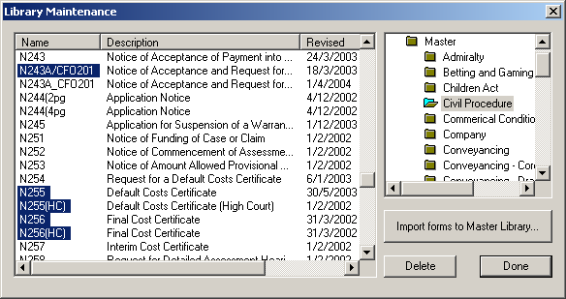
Example Screen Shot – Library Maintenance:

If you have any problems please contact Oyez Legal Software Support on 020 7556 3201

