EFIS No.14/2003

March 2003

RANGE: CIVIL PROCEDURE

CFO100 - Request for Lodgment
CFO200 - Payment Schedule
N9B - Defence and Counterclaim (Specified Amount)
N9D - Defence and Counterclaim (Unspecified Amount, Non-Money and Return of Goods claim)

N20 - Witness Summons
N242 - Notice of Payment into Court (under Order Part 37)
N242A - Notice of Payment into Court (in settlement Part 36)
N243A/CFO201 - Notice of Acceptance and Request for Payment (Part 36)
N292 - Order on Settlement on Behalf of Child or Patient
EX140 - Record of Examination (Individual)
EX141 - Record of Examination (Officer of Company or Corporation)

The Court Service has amended the above forms to take account of Part 36 and Part 37 of the Civil Procedure Rules, which will come into force on 1st April.

In future, all payments into court will be made directly to the Court Funds Office so these amended forms reflect the procedural changes which will be introduced in April by the Court Funds (Amendment) Rules 2003.

Practitioners are advised not to use the amended forms until April and should not use their current forms after 1st April.

The Court Funds (Amendment) Rules 2003 will come into force on 1st April.

In future, payments into court under Parts 36 and 37 of the Civil Procedure Rules 1998 will no longer be made to the local district registry or County Court but to the Court Funds Office, except where a litigant in person makes a payment into court.

The Court Service has adapted the Court Funds Office forms listed above to take account of these changes to the Court Funds Rules 1987.

Form N243A/CFO201 is now combined and replaces existing forms N243A and CFO201, which should now be deleted. Please see deletion instructions overleaf.

Unrelated to the above changes to CPR forms, the Court Service has amended N9B and N9D to incorporate a box for the fee on a counterclaim to be inserted. Whilst existing forms can continue to be used, we recommend that you use the amended versions supplied on this disk.

The Court Service has also conducted a review of the instructions to a witness upon whom N20 is served and the amended version of N20 is also included on this disk.

Also a minor amendments have been made to the N243, N316 and N265.

You can visit www.oyezforms.co.uk to keep up to date with the latest news and what new services Oyezforms has to offer, or to register for email notification of EFIS updates. To register for email notification updates, mail us at: legal.email@oyezstraker.co.uk, including your company name and oyez account number in the message text.

Printing Problems running V8.03M, V8.03N OR V8.03U
We recommend that you upgrade to V8.03X if you receive any error message when either initialising or printing with Oyezforms. To obtain an upgrade, please visit http://www.oyezforms.co.uk/ or contact Support on Tel: 020 7556 3201 or email mailto:support.legal.software@oyezstraker.co.uk
New Ranges
Due to popular demand we have added the following ranges: Insolvency Partnership and Estates, Personal Injury/Consumer Protection, Court Funds Office, Licensing, Betting and Gaming, Limited Liability Partnership, Admiralty, Domestic Proceedings, Commercial Conditions – Law Society and Personal Injury – Law Society forms to OyezForms. For a list of these forms please access Help>Oyez Forms Catalogue once your enclosed update disk has been installed. Please contact the Sales Department on 020 7556 3200 if you would like a quote for any of these new ranges.

An Online Forms Catalogue, updated automatically with each EFIS, is available within the OyezForms >HELP Menu or START>PROGRAMS>OYEZLEGALFORMS>OYEZFORMS CATALOGUE.

Importing Forms – Version 7&8 (32Bit software for Win95/98/NT4/2000/XP)

- Start the OyezForms software (if you are running a networked copy of the software only one user has the software open at this point).
- Insert the update disk into your floppy drive.
- Select Admin and then Import new forms…
- The Import new forms dialog box will appear and a list of the forms contained on the update disk will be displayed. Click Select All and then Import.
- Once imported you will be asked if there are any more forms to import. If there are click Yes; insert the next disk and select OK.
- The screen will refresh to display a new list of forms. Follow step 4 again.
- Once the disk(s) have all been imported select No.

Deleting Files under Windows 95/98/2000/NT/XP for Version 7 & 8

- Click ADMIN>LIBRARY MAINTENANCE, then double-click MASTER>CIVIL PROCEDURE
- Highlight obsolete forms using the Shift and Page Down or Arrow Down keys onthe keyboard and press the Delete button on screen.
- The software will pop-up two ‘Are you Sure’ messages, click Yes to both.
- Repeat for subsequent forms.
- Finally, click Done button on screen.

Example Screen Shot – Library Maintenance:
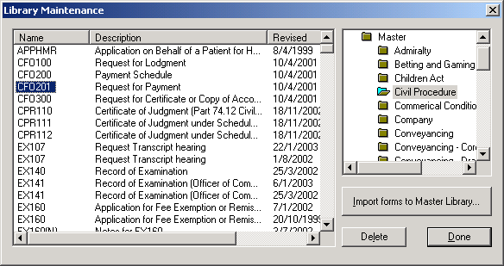

If you have any problems please contact Oyez Legal Software on 020 7556 3201

